1. <https://www.geeksforgeeks.org/lucky-numbers/>

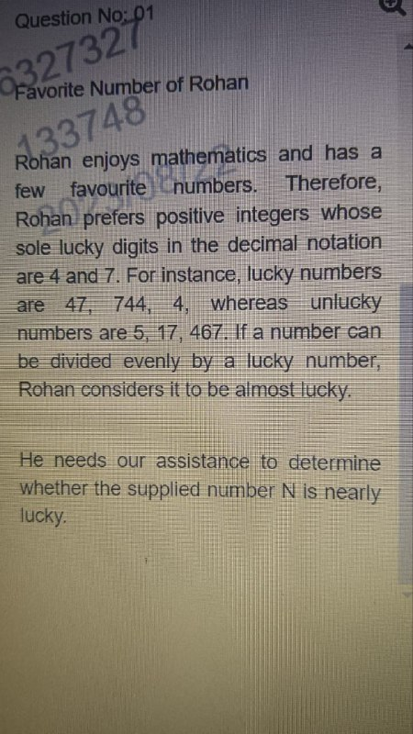

1. Palindrome peak element lucky n unlucky no array list (<https://leetcode.com/problems/find-peak-element/> )
2. 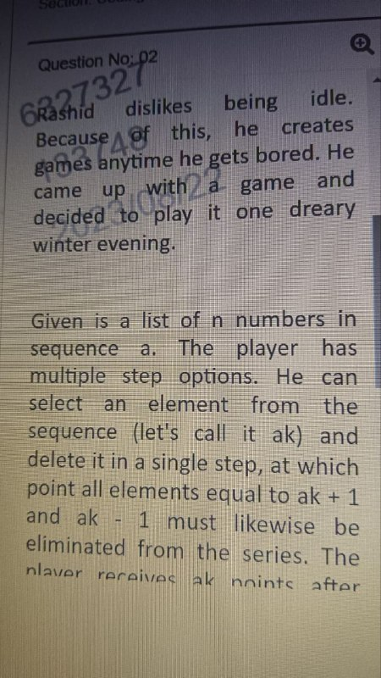

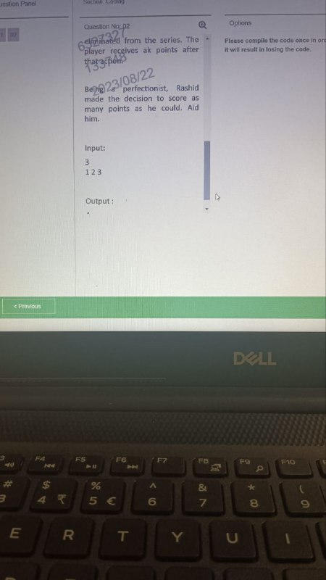

1. https://www.codingninjas.com/studio/problem-details/boredom_920547
2. string palindrome check
3. count the digits in a number
4. And other is   
   We have two arrays  
   E and J, E array have N size and J array have N-1 size and we have a devil energy as a integer number.  
   Initially the energy is 0 then   
   In every hour we have to gain energy from the E array where each index represents different cities.if the energy is enough to make the jump from one city to next then then subtract the jump energy that comes from J array then now onwards add that city energy to our energy variable.  
   When our energy is greater than or equal to devil energy return the number of hrs required to kill that hrs.  
   The array is in non- decreasing order.  
     
   Input format  
   3 20  
   5 7 8  
   10 11  
     
   Output:  
   7 hrs  
     
     
   Explanation: 1st hr energy is 5  
   2 nd hr energy is 10  
   Now we jump because we have enough energy  
   Now we have 0 energy because 10 is loosing in city change  
   Now in 3hr and 4 hr   
   We gain 14 energy  
   Now again jump we have 3 enrgy now in 5 hr we have 8+3  
   In 6hr   
   8+3+8  
   In 7hr   
   8+8+8+3=27  
   So our answer is 7
5. GCD,and stair case problem are repeatededly asked in slots so focus on them also

Coding:-

C++ code to find the total number of pairs of a,b such that the gcd(a,b)=x where 1<a<b<=l:

int gcd(int a, int b) {

while (b) {

a = b;

b = a % b;

}

return a;

}

int count_pairs(int x, int l) {

int count = 0;

for (int a = 2; a <= l; a++) {

for (int b = a + 1; b <= l; b++) {

if (gcd(a, b) == x) {

count++;

}

}

} return count;

}

int main() {

int x, l;

cin >> x >> l;

cout << count_pairs(x, l) << endl;

return 0;

}

2

int right_count(string s) {

int count = 0;

for (int i = 0; i < s.length(); i++) {

for (int j = i + 1; j < s.length(); j++) {

if (s[i] == s[j]) {

count++;

}

}

}

return count;

}

1. Chocolate distribution : <https://youtu.be/k8-eY9Nk_mQ?si=Zl9m-eZbhXQ69FYr> , <https://www.geeksforgeeks.org/chocolate-distribution-problem/>

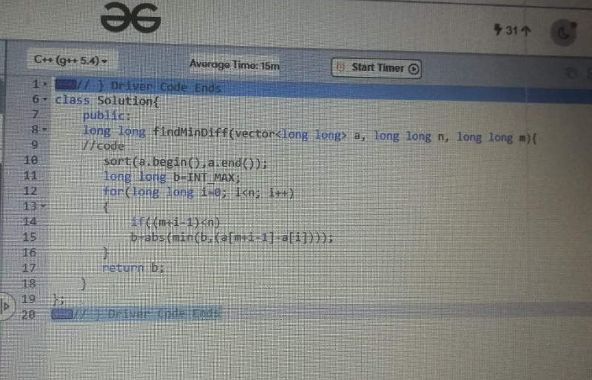

1. 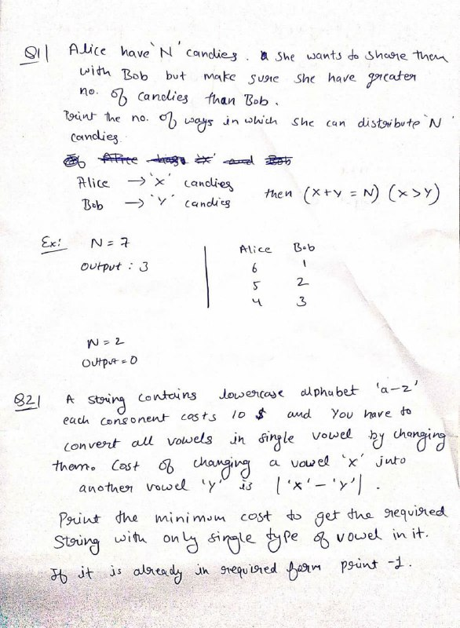

2 ans : 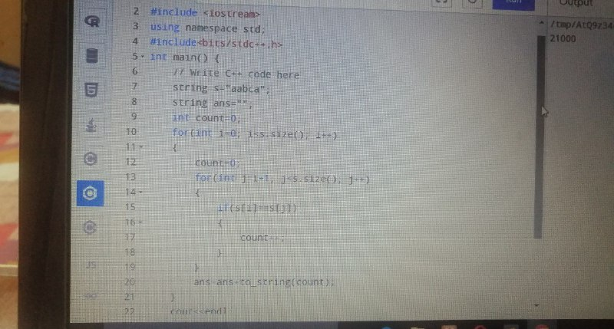

1. 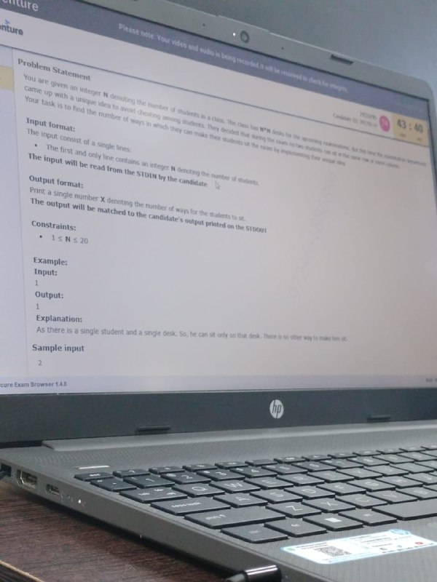
2. Find the pairs with given sum : <https://youtu.be/T-jQ8tfcOII> , <https://www.geeksforgeeks.org/print-all-pairs-with-given-sum/>
3. 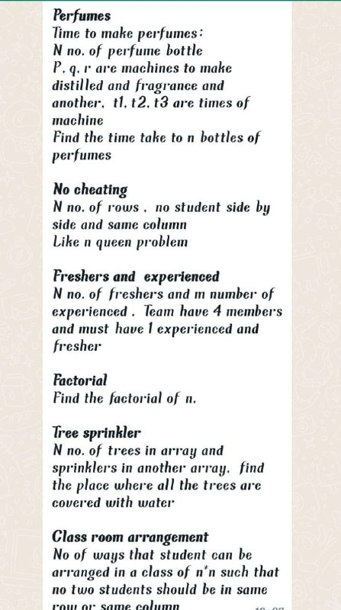
4. Most of the questions are repeating, so who all have next on campus placements please go through   
   1. Chocolate distribution  
   2. Perfume problem  
   3. Class room arrangement (factorial)  
   4. Password checker
5. 1. Find No of ways students arrangement in exam to avoid cheating.  
   2. How many ways for Chocolate distribution to students without getting same no chocolates for any two students06:44 PM
6. 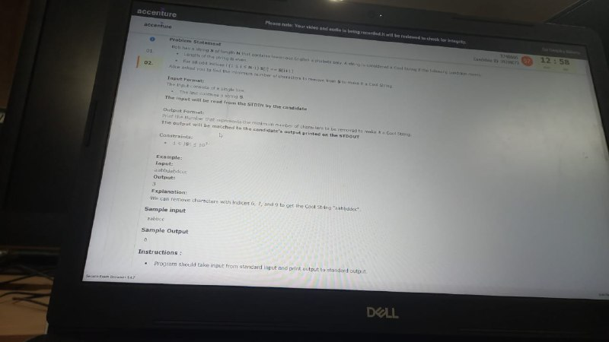

Sol : 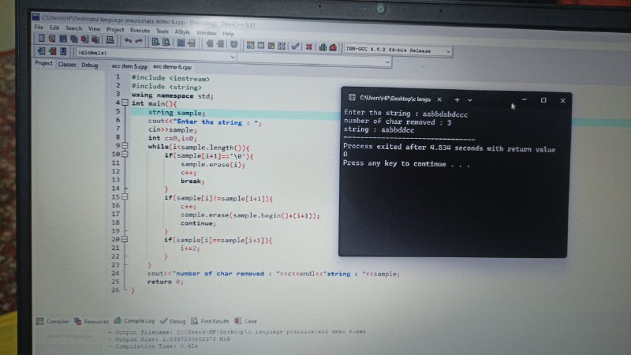

15) 

Sol : 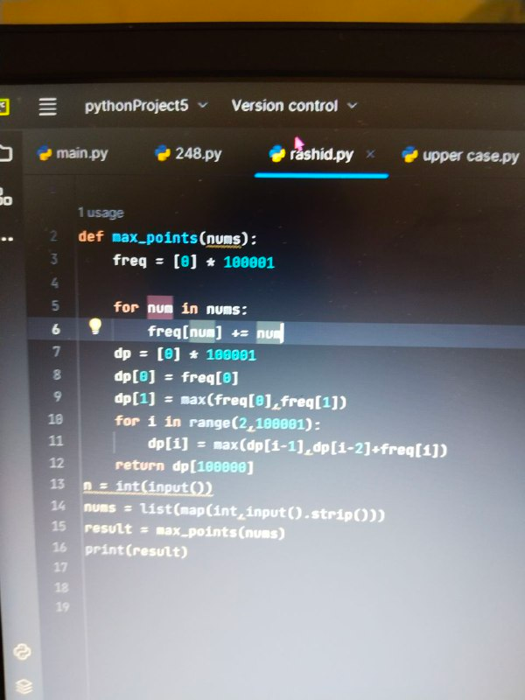

1. <https://www.codingninjas.com/studio/problem-details/boredom_920547>
2. Ek array tha usme kuch subarray element ko sum krke array ke elements se replace Krna tha taki array increasing order me ho jaye
3. 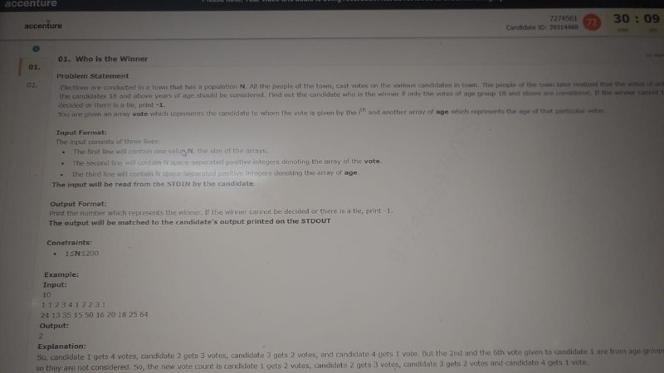
4. 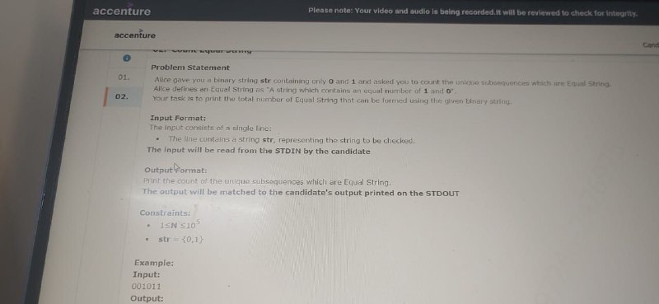

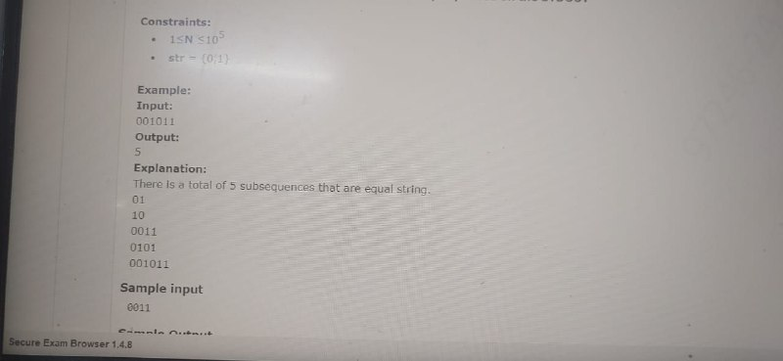

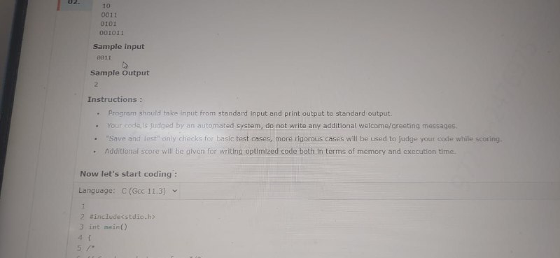

1. 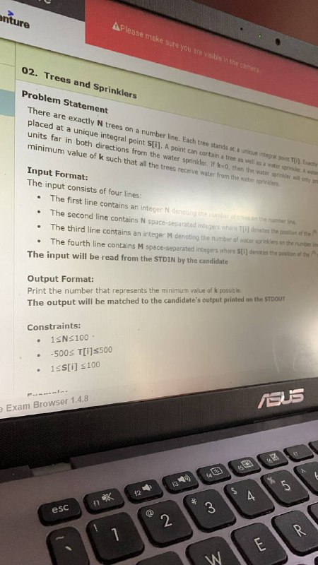



1. alice is planning to organize a contest with 4 players in each team .there are two types of player name experienced and fresheres .to make the contest unbiased alice wants to have a team in such a way that each team must contain atleast 1 experienced and 1 freshers .you are given N number of experienced and M number of freshers.Your task is determine the maximum number of team formation possible.NOTE: no member can join more than one team. Input format:*the first line contain the two separated integer N and M.Ouput format :print the number that represents the maximum number of team formation possible. TESTCASE INPUT N=5,M=5 OUPUT is 2
2. 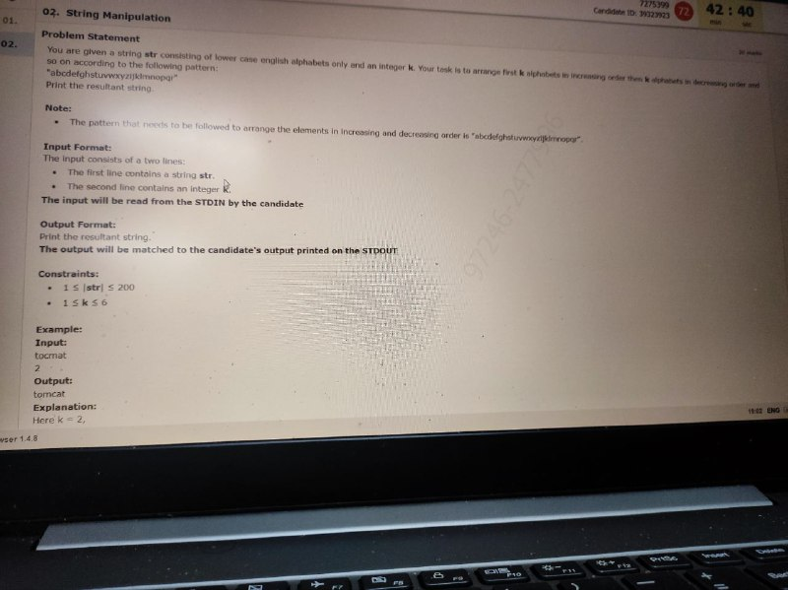

Sol : 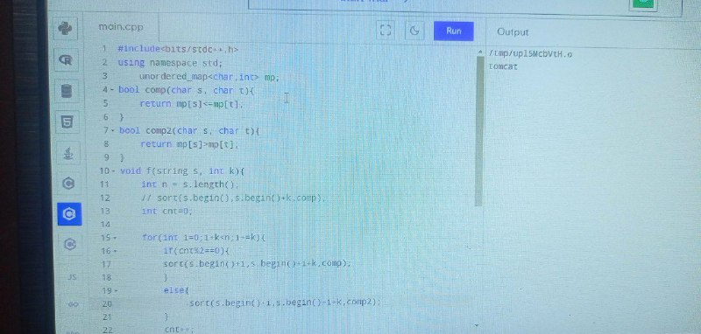

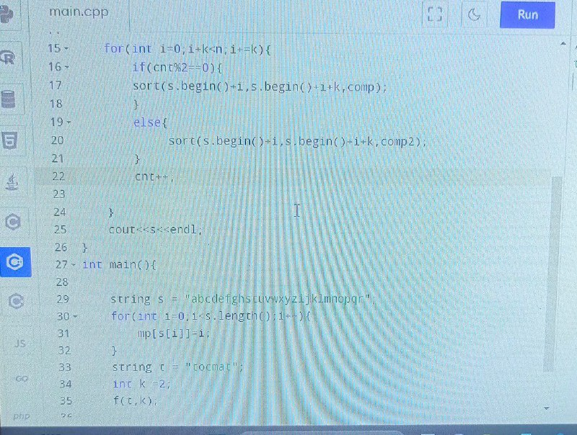

Other sol : int main(){

string ans="tshcat",sample="abcdefghstuvwxyzijklmnopqr";

int k=3;

for(int j=0;j<k-1;j++){

for(int i=1;i<k;i++){

if(sample.find(ans[i])<sample.find(ans[i-1])){

swap(ans[i],ans[i-1]);

}

}

}

cout<<ans;

return 0;

}

1. 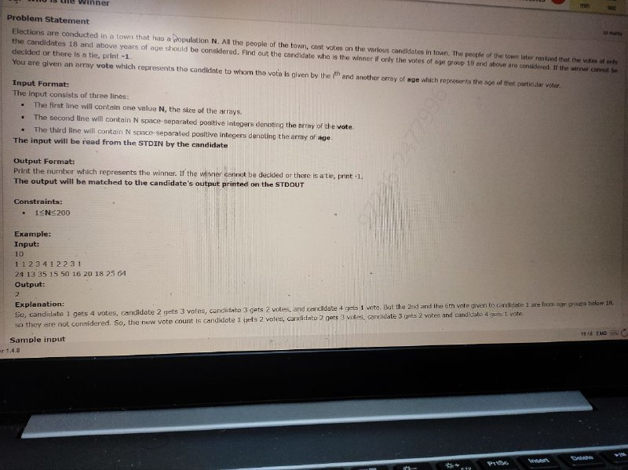

Sol : 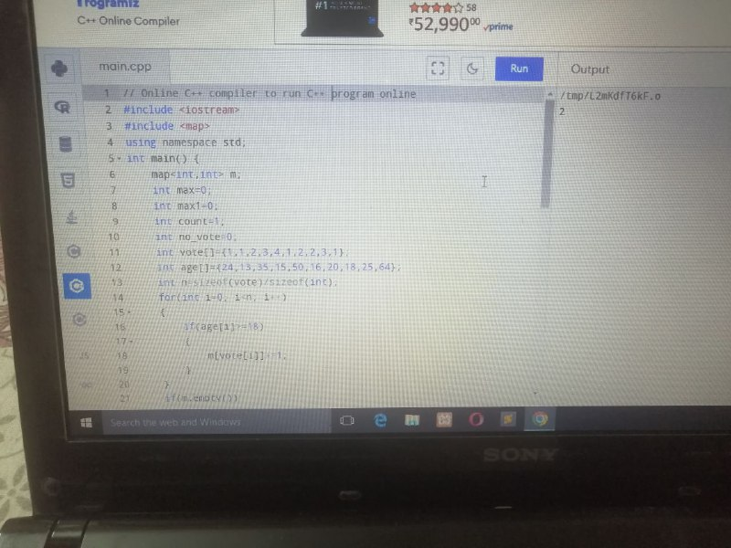

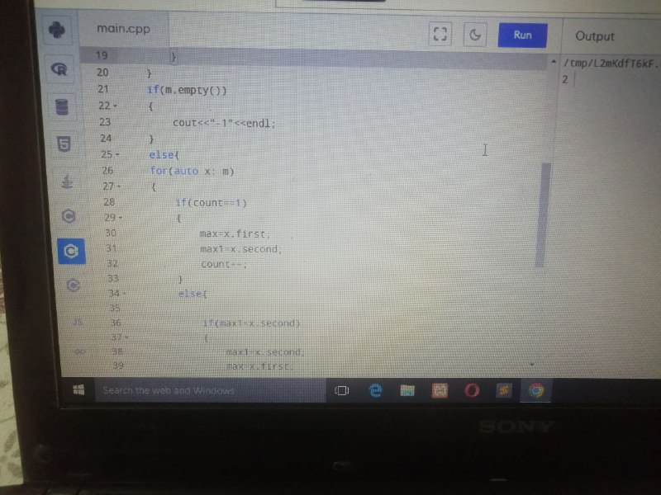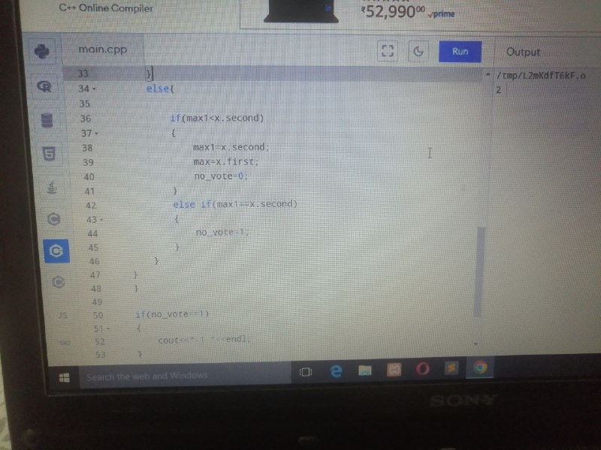

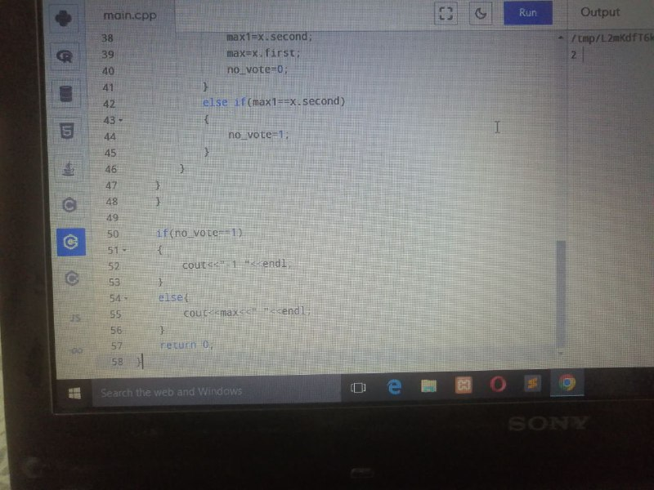

1. 
2. 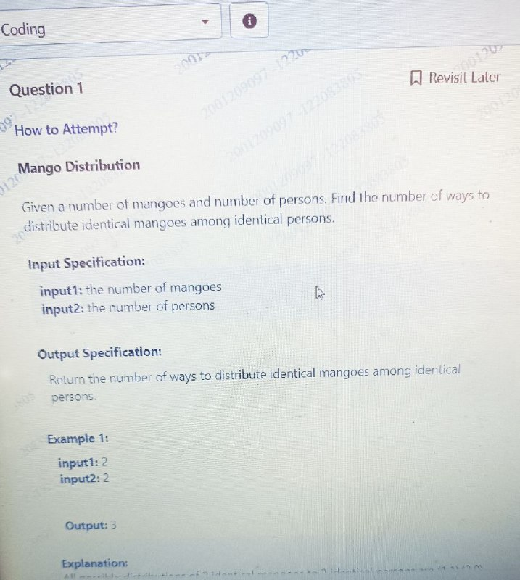
3. 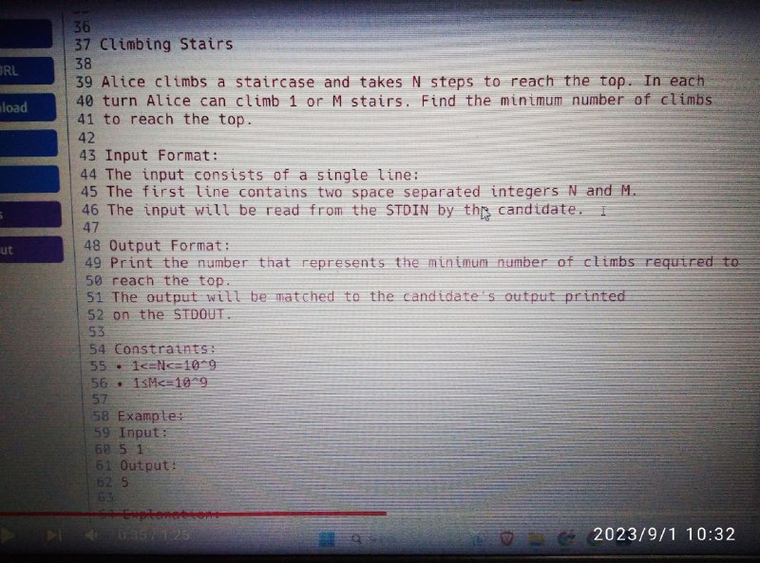
4. 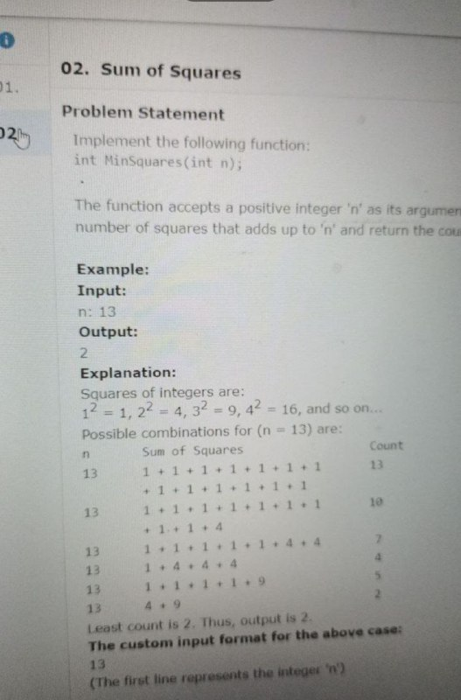

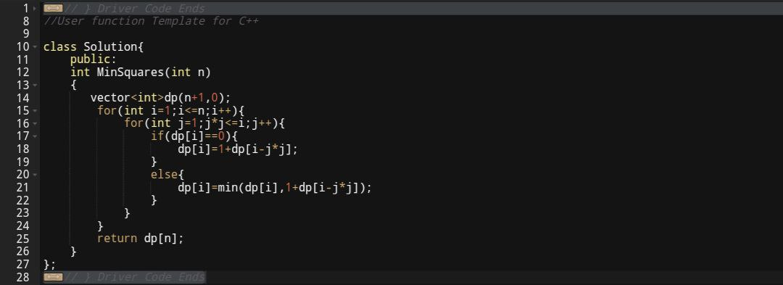

Other sol: int MinSquares(int n) {

if (n == 0) {

return 0;

}

int minCount = INT_MAX;

for (int i = 1; i * i <= n; i++) {

int Count = 1 + MinSquares(n - i * i);

minCount = min(minCount,Count);

}

return minCount;

}

int main() {

int n = 13;

int result = MinSquares(n);

cout <<result << endl;

return 0;

}

1. 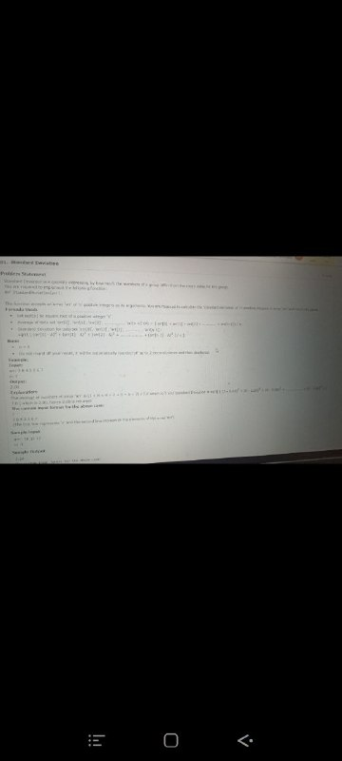

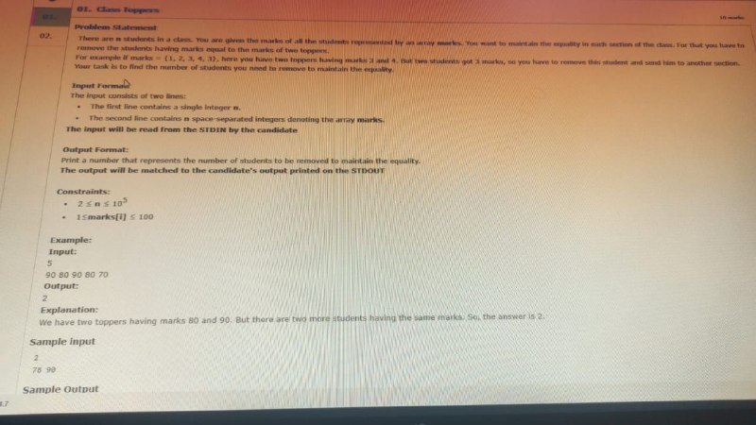

#include <iostream>  
#include <vector>  
  
int StudentsToRemove(std::vector<int>& arr) {  
if (arr.size() == 2)  
return 0;  
  
int topper1 = 0;  
int topper2 = 0;  
  
for (int i = 0; i < arr.size(); i++) {  
if (arr[i] > topper1) {  
topper2 = topper1;  
topper1 = arr[i];  
} else if (arr[i] > topper2 && arr[i] < topper1) {  
topper2 = arr[i];  
}  
}  
  
int remove = 0;  
  
for (int i = 0; i < arr.size(); i++) {  
if (arr[i] == topper1 || arr[i] == topper2) {  
remove++;  
}  
}  
  
if (remove > 2)  
return remove - 2;  
  
return remove;  
}  
  
int main() {  
std::cout << "Enter marks of students" << std::endl;  
int n;  
std::cin >> n;  
std::vector<int> arr(n);  
  
for (int i = 0; i < n; i++) {  
std::cin >> arr[i];  
}  
  
std::cout << StudentsToRemove(arr) << std::endl;  
  
return 0;  
}

31)

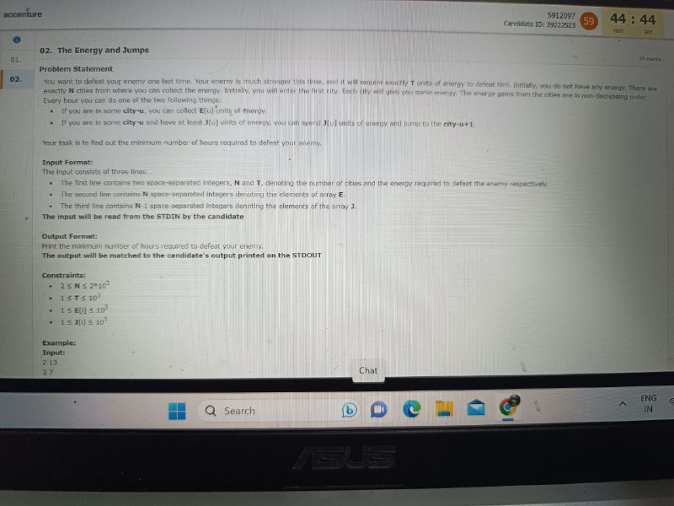

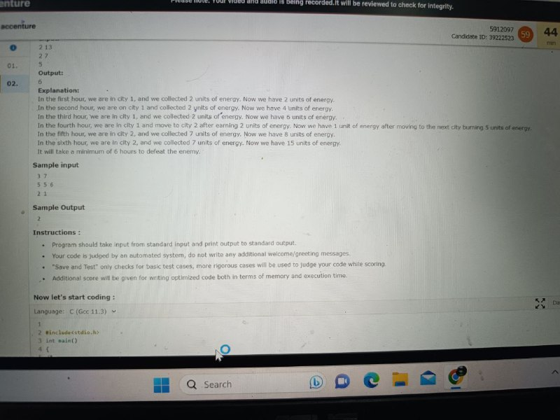

32)

